Erasmus Work Placement Offer
In Erasmus office of Istanbul Bilgi University 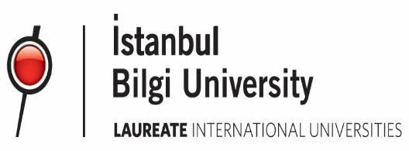
The Work Placement Program is a great way to impress employers and provides you excellent working experience in an office environment. Besides the professional skills you will develop during this experience, you will also benefit from advantages such as an Erasmus mobility grant provided by your home institution, a meal card, free shuttle services to Bilgi campuses provided by BILGI, and, last but not least, ECTS credits which can be transferred to your home university. Erasmus interns will not generate any financial reimbursements for the department. The intern may receive an Erasmus mobility grant to partly cover the costs of travel and accommodation. Erasmus mobility grants are managed by the intern’s home university. Please find below the description of duties and responsibilities of your future internship. If you are interested in the Erasmus Work Placement program, please send your CV and your possible internship dates to: incoming-intern@bilgi.edu.tr
EMPLOYER INFORMATION
Name of organization | Istanbul Bilgi University / Global Talent Management Center - Erasmus Office
Address | Santral Kampüs, Eski Silahtarağa Elektrik Santrali, Kazim Karabekir Cad. No: 2/13, 34060 Eyüp - İstanbul TURKEY
Contact Person | Gözde Topraktepe  Email: incoming-intern@bilgi.edu.tr Website: www.bilgi.edu.tr/en
Duration | The placement period will last at least 4 months, but interns who are available for a longer  period will be preferred.
Requirements | English - Advanced  Turkish - Intermediate (not mandatory, but preferred)
Working Hours | Monday-Friday, 09:00-17:00
Job description | Chosen student will be responsible for creating, editing and managing content for the school’s web presence. The intern is expected to be experienced at Photoshop and video-making tools to an advanced level, able to manage social pages such as Instagram and Facebook and compose newsletters and leaflets for events. They will assist the operation of events of the international centre; support outgoing and incoming students during application periods and on exchange preparations; assist with the marketing of study abroad programs using and devoloping new approaches to attract more incoming and outgoing students; and creating social media content.
Free shuttle services | santralistanbul <> Beşiktaş  santralistanbul <> Kuştepe-Trump Towers  santralistanbul <> Dolapdere  santralistanbul <> Halıcıoğlu  santralistanbul <> santralistanbul Annex  santralistanbul <> Pangaltı (Next to Ramada Hotel - In front of Finansbank)  For the shuttle hours follow https://www.bilgi.edu.tr/en/life-at-bilgi/transportation/shuttle/

International Office - Istanbul Bilgi University

