UNIVERSIDAD  ZARAGOZA | TRAINING AGREEMENT AND QUALITY COMMITMENT  LLP ERASMUS PLACEMENTS  Academic Year 2026-2027 | Educación y Cultura  Programa en el ámbito del Aprendizaje Permanente ERASMUS

II. DETAILS OF THE PROPOSED TRAINING PROGRAMME ABROAD

Host organization:
Sección de Griego Moderno
Centro Universitario de Lenguas Modernas
Universidad de Zaragoza
Campus San Francisco
Edificio interfacultades, despacho 409 (4ª planta)
C/ Pedro Cerbuna, 12
50009 Zaragoza
España
Teléfono: + 34 876 553112
Dir. email: ecasasin@unizar.es

Reference: Greek language.

Coordinator’s name:
Mr. Ernesto Casasín Segurado., Coordinator of the Department of Modern Greek of CULM (ecasasin@unizar.es, +34 976 553 112)

Planned dates of the placement period: from September 2026 until June 2027 included, for a 4 or more month-period.

- Knowledge, skills and competence to be acquired:
- Greek is required as native or C1 level.
- We are looking for a postgraduate or a final year student mainly in Philology, in order to practice Modern Greek with students as a second/foreign language.
- Good communication skills are required.
- Computer skills are also required.
- Optional knowledge of Spanish language.

- Detailed programme of the training period and Tasks of the trainee:
- Personal review of Greek Conversation courses on-line.
- Teaching of Greek through Moodle platform.
- Review of the Greek lessons through Moodle platform.
- Various activities of the Department.
- Conversation classes with students.
- Taking part in activities like, translate and subtitle Greek films, elaborate the study program, organize final exams, digitalize auxiliary study material.
- Participation in the developing process of new courses.
- Other related tasks

Contact language: Greek or English. Spanish will be valued.
Working hours per week: 35.

- Monitoring and evaluation plan:
To be determined.

III. COMMITMENTS OF THE THREE PARTIES

The host organization
The student will receive a financial support for his/her placement: NO
The student will receive a contribution in kind for his/her placement: YES
Possibility to attend classes of the languages taught at the centre including: English, Arabic, Chinese, French, Italian, German, Japanese, Portuguese and Russian.

Name and position of the mentor: Mr. Ernesto Casasin Segurado. Coordinator of the Greek department.
Number of permanent staff in the department (team) hosting the student: 1
Number of other students/trainees hosted at the same time in the department (team) hosting the student: 1, 2, or 3

We confirm that this proposed training programme is approved. On completion of the training programme the organization will issue a Certificate to the student.

Coordinator’s name, function and signature


Date: 5/12/2025
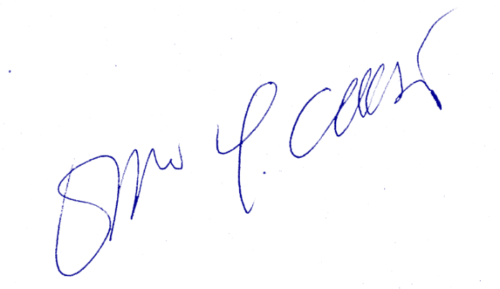

Mr. Ernesto Casasín Segurado
Sección de Griego Moderno
Centro Universitario de Lenguas Modernas
Universidad de Zaragoza
Campus San Francisco
Edificio interfacultades, despacho 409 (4ª planta)
C/ Pedro Cerbuna, 12
50009 Zaragoza
España
Teléfono: + 34 876 553112
Dir. email: ecasasin@unizar.es

