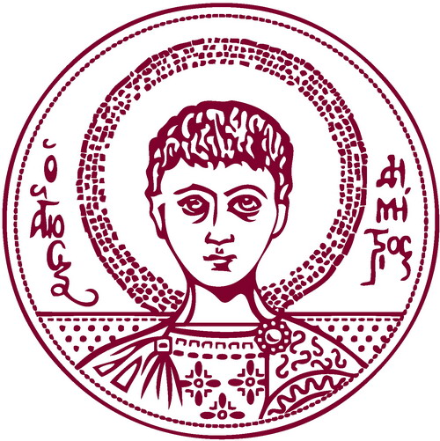 |   ARISTOTLE UNIVERSITY OF THESSALONIKI  International Credit Mobility  STAFF MOBILITY FOR TEACHING  TEACHING CERTIFICATE  Academic Year 2024-2025

Name of teaching staff member:
HOME Institution: | ARISTOTLE UNIVERSITY OF THESSALONIKI
ERASMUS code: | G THESSAL01
HOST Institution:
Department/Faculty:
ID Erasmus code (if applicable):
Subject area code:

Number of teaching days (min. 5 days): _________

Total number of teaching hours (min. 8 hours per week): __________

First date of teaching: _____/_____/_____

Last date of teaching: _____/_____/_____

Teaching Language: _________________________________________
Level of students: Undergraduate 
Postgraduate 
Doctoral 
Combination 

Number of students benefiting from the teaching programme: _______

Content of the teaching programme:

 | Name | Signature | Date | Stamp
Dean of Faculty/Head of School of Host Institution

Please complete and return this form after the visit to:

Department of European Educational Programmes tel.: +30-2310-995287
Aristotle University of Thessaloniki e-mail: eurep-projects@auth.gr

GR-54124, Thessaloniki, Greece

