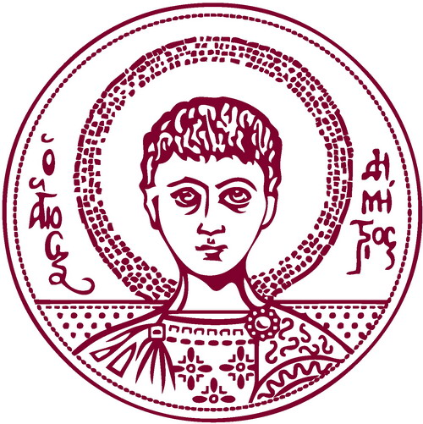 |   ARISTOTLE UNIVERSITY OF THESSALONIKI  STAFF MOBILITY FOR TEACHING  TEACHING CERTIFICATE  Academic Year 2024-2025

Name of teaching staff member:
HOME Institution:
ERASMUS code (if applicable):
HOST Institution: | ARISTOTLE UNIVERSITY OF THESSALONIKI
Department/Faculty:
ID Erasmus code: | G THESSAL01
Subject area code:

Number of teaching days (min. 2 days): _________

Total number of teaching hours (min. 8 hours): __________

First date of teaching: _____/_____/_____

Last date of teaching: _____/_____/_____

Teaching Language: _________________________________________
Level of students: Undergraduate 
Postgraduate 
Doctoral 
Combination 

Number of students benefiting from the teaching programme: _______

Content of the teaching programme:

 | Name | Signature | Date | Stamp
Dean of Faculty/Head of School of Host Institution

